



# SRM Institute of Science and Technology College of Engineering and Technology

**DEPARTMENT OF ELECTRONICS AND COMMUNICATION ENGINEERING**

## MINI PROJECT REPORT

**ODD Semester, 2021-22**

Lab code & Sub Name : **18ECC204J – DIGITAL SIGNAL PROCESSING**

Year & Semester : 3rd & 5th

Mini Project Title : Application of Sound Effect on a

audio file

Lab Supervisor : Mrs.D.VIJAYALAKSHMI

Team Members :Pushpal Das ( RA1911004010565 )

| **Reg. No** |  | **RA1911004010565**  **Pushpal Das** |  |
| --- | --- | --- | --- |
| **Mark split up** |
| **Novelty in the Mini project work**  **(2 marks)** |  |  |  |
| **Level of understanding (4 marks)** |  |  |  |
| **Contribution to the project**  **(2 Marks)** |  |  |  |
| **Report writing (2 Marks)** |  |  |  |
| **Total (10 Marks)** |  |  |  |

**Date: Signature of Lab In charge**



**Application of Sound Effect on a Audio file**

**OBJECTIVE :**

To add Sound effect on audio file using Scilab

## INTRODUCTION :

Musical tones have three identifying characteristics; volume, pitch and timbre. Volume is power, or the amplitude of the corresponding wave, and it is measured in decibels. Frequency is the measure of how "high" or "low" a tone is, which is measured in hertz (Hz). The third identifying feature, timbre, stems from the fact that musical sounds are made up of many different sine waves (as opposed to a sound that is made of just one sine wave). Each instrument has a characteristic pattern of sine waves, which is what makes it possible to distinguish between an oboe and an electric guitar playing the same note.

## ABSTRACT :

The basic idea of project is that it exploits the fact that each Raag is associated with certain frequency and this frequency is processed further, to achieve the objective. It also notifies us if he goes wrong according to the laws of Indian Classical Music in his practice sessions. The musical notes played by us are nothing but the frequencies or the pitch to be extracted and processed. As the project involves intensive audio processing, DSP (Digital Signal Processing) Kit is used as hardware component, while for software assistance SCILAB is used.

## BLOCK DIAGRAM :

The step by step working and analysis of basic musical tone generator. The major blocks would include Audio signal, Frequency extraction, Raag authentication and at the end the displaying content in the form of musical note.

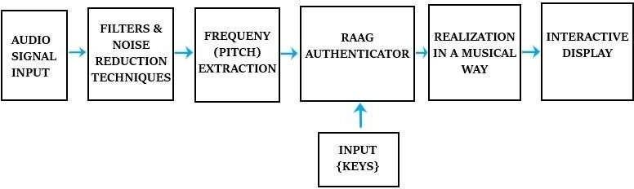



* The input sound is taken through the ‘Audio Signal Input’, which is nothing but the microphone.
* This output is then given to the ‘Filter and Noise Reduction Block’, which consists of ‘Low Pass Filter’, in order to remove noise and other disturbances.
* The ‘Frequency (Pitch) extraction’ block is used to take out the frequencies from the clean audio signal (sound).
* The ‘RAAG Authenticator’ would consist of laws and regulations of Indian Classical Music. A database of music would be stored in this block, and would compare with the music and thereby indicating whether it is correct or not.
* The ‘Input {Keys}’ block would be interfacing of Keypad. It would have options to select the base frequency and the type of ‘RAAG’ which we will select after recording and then compare.
* The block ‘Realization in a musical way’ is used, as we have to display the Sur/Notes (Sa, Re, Ga, etc) rather than the musical frequency. This objective would be achieved by coding. For instance, if the tune played is at 440Hz, rather than displaying 440Hz, would display ‘Sa’ on the device.
* These Sur/Notes will be then displayed on the PC Terminal and it will also indicate whether the tune played is correct or not.

## WORKING PRINCIPLE :

Sampling frequency is the reduction of continuous time signal to discrete time. Sampling can be done for function varying in space, time or any other dimension.

The program realization in a musical way is used, as we have to display the Sur/Notes rather than the musical frequency. This objective would be achieved by coding.

For instance, if the tune played is at 440Hz, rather than displaying 440Hz, we would display ‘Sa’ on our device. These Sur/Notes will be then displayed on the PC Terminal and it will also indicate whether the tune played is correct or not.



## CODE :

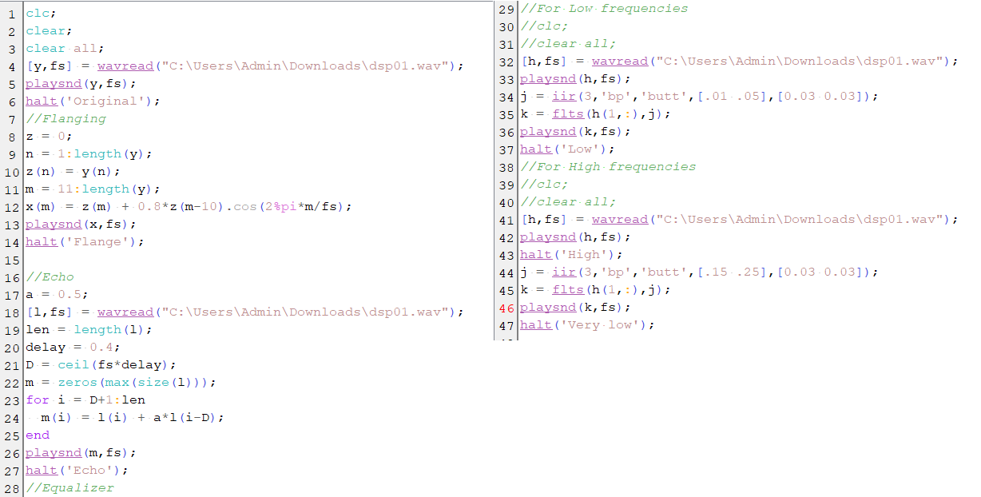



.

## CONCLUSION :

The methodology used in this design is helpful and successful. Creating the algorithm in a SCILAB .m file was instrumental in verifying the outputs over the hardware. The Note and Pitch Detection (Frequency Extraction), Raag Identification along with error correction was successfully implemented in SCILAB.

## REFERENCE :

Drive link - [DSP - Google Drive](https://drive.google.com/drive/folders/1hFw1jrmAz0B-srUOE7wJbU97KFqoBQ9N)